**Learning Outcome:**

By the end of this practical, student will be able to:

Construct a software application using the Python programming language (CLO1, P3, PLO3).

|  |
| --- |
| **Question 1**  Construct a package and write modules to calculate student’s grade. Please refer to the following requirements:     1. Create a package called **pack1.** 2. Create **grade.py** module and keep it in **pack1.**    1. In this module (grade.py), create a function **result ()** to calculate and display the grade and the user’s name.    2. Your function must receive an arguments name and marks from the user. 3. Create a **UserResult.py** module (outside of pack1 package)    1. This module (UserResult.py) will get an input name and marks from a user. It will also call the result () function in grade module.     *(Hint: For grade, refer Politeknik system grading).*  **(25 marks)** |

|  |  |  |  |
| --- | --- | --- | --- |
|  | | |  |
| **CODE / COURSE** | **DFN40323- PROGRAMMING ESSENTIALS IN PYTHON** | **PRACTICAL TASK** | **~~4~~** |
| **PROGRAM / CLASS** | **DDT4** | **DURATION** | **3 HOURS** |
| **STUDENT’S NAME** | **1) TARINI A/P ASOKUMAR**  **2) MUHAMMAD AFIQ MUHAIMIN BIN MOHD ZAINI** | **CLO 1** | **P3** |
| **REG. NO.** | **1) 32DDT20F2006**  **2) 32DDT20F2029** | **TOTAL MARKS** | **/75** |
| **LECTURER’S NAME** | **SHARIZAN BINTI ABDUL JAMIL** |

**Instructions:**

Answer all the questions given. Students need to discuss in groups of two (2) and upload the findings of the discussion in report and .py file through CIDOS. Students will be accessed according to the Rubric given.

|  |
| --- |
| **SOURCE CODE & OUTPUT:**  Folder structure      **grade.py**    UserResult.py    Output |
| **Question 2**    Construct a package and write modules to calculate volume of cylinder. Please refer to the following requirements:     1. Create a package called **pack2.** 2. Create **volume.py** module and keep it in **pack2.**    1. In this module (volume.py), create a function **calcVolume ()** to calculate and display the volume of cylinder. Use the formula (volumeOfCylinder = πr2h)    2. You also need to **built-in module** in Python for **constant π.**    3. Your function must receive an arguments height and radius from the user. 3. Create a **calculate.py** module (outside of pack2 package)    1. This module will get an input height and radius from a user. It will also called the calcVolume() function in the volume module.     **(25 marks)** |

|  |
| --- |
| **SOURCE CODE & OUTPUT:**  **Folder Structure** |

**Question 3**

Construct a module t

o generates a random number between 1

and 6 (including 1 and 6)

for

computer player

.

Ask the

user

player

to choose the number

between 1 and 6

, then identify

i

f

the computer wins, it gets 1 point while player wins, it gets 1 point. The game

will

repeat in

th

ree (3) times

and when the game ends, it will d

isplay the score

of each player.

T

he coding

also

must have

the exception handling:

a.

Display a message “You input other than integer” if the user input other than

integer.

b.

Display the message “Thank You for Pl

aying” regardless if it raises an error or not.

Sample output for correct input:

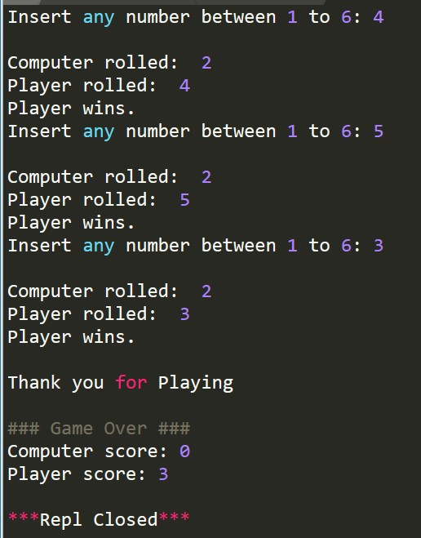

Sample output for wrong input:

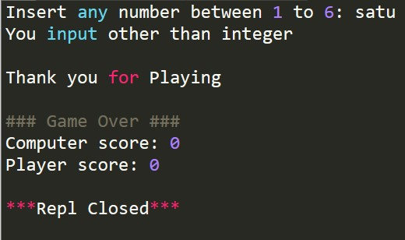

**(25**

**marks**

**)**

|  |
| --- |
| **SOURCE CODE & OUTPUT:**      Wrong Input |
| **CONCLUSION:**  In conclusion, for the first and second question we learned on how to utilize package to make our code usable in any code and clean up our code and utilize python’s built in method which is math.pi() for our pi number and math.pow().  In the third question we learned on how to use exception handling and random module to make random guesses throught the code |